**International Expansion**



**Inception Of Caterpillar Inc.**

Caterpillar Inc. is an American multinational corporation specializing in manufacturing heavy equipment for industries such as construction, mining, and agriculture. The company was founded in 1925 by two California-based companies, Holt Manufacturing Company and C. L. Best Tractor Co. These companies were leading manufacturers of agricultural equipment at the time, but joined forces to create a more diverse product line and increase their market share.

From its inception, Caterpillar focused on expanding its business to reach a global market. In 1931, the company established its first overseas facility in Canada, which was followed by the opening of a plant in England in 1950. This marked the beginning of Caterpillar's international expansion journey.

Throughout the 20th century, Caterpillar continued to expand its presence in various regions of the world. In 1954, the company opened its first manufacturing facility in Australia and later expanded to Asia, establishing facilities in Japan and Singapore in the 1960s.

During the 1960s, the company also began to expand its distribution network globally, partnering with local dealers in different countries to sell and service its products. This distribution model proved to be successful for Caterpillar and helped the company establish a strong presence in countries where it did not have manufacturing facilities.

In the 1970s and 1980s, Caterpillar further expanded its global reach by entering into joint ventures and forming strategic alliances with international companies. These partnerships allowed the company to gain access to new markets, technology, and resources. One notable joint venture during this time was with Mitsubishi in Japan, which helped Caterpillar establish a strong foothold in the Japanese market.

The 1990s brought significant changes to Caterpillar's international expansion strategy. The collapse of the Soviet Union presented new opportunities for the company to enter into markets in Eastern Europe and Russia. In 1991, Caterpillar acquired an engine manufacturing facility in Russia, marking its first wholly-owned operation in the country.

The 2000s saw a significant focus on emerging markets for Caterpillar's international growth. The company targeted countries like China, India, and Brazil, where there was a growing demand for its products. In 2004, Caterpillar opened a manufacturing plant in China and began to invest heavily in research and development to meet the specific needs of these emerging markets.

Today, Caterpillar has a presence in more than 190 countries and has continued to expand its global reach through strategic investments and partnerships. In 2015, the company formed a joint venture with a Brazilian-based company to expand its presence in Latin America.

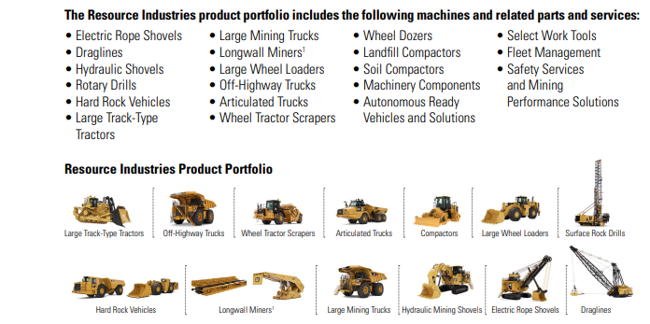

In addition to its expansion through physical presence, Caterpillar has also embraced digital technologies to reach a wider global customer base. The company offers online and mobile platforms for customers to access information, purchase products, and request support services from anywhere in the world.

In conclusion, Caterpillar's international expansion journey has been a key factor in its success as a global manufacturing giant. From its first overseas facility in Canada to its current presence in over 190 countries, the company has strategically expanded its reach to meet the demands of a global market. Through joint ventures, strategic partnerships, and investments in emerging markets, Caterpillar has solidified its position as a top player in the heavy equipment industry.

**Countries Of Expansion:**

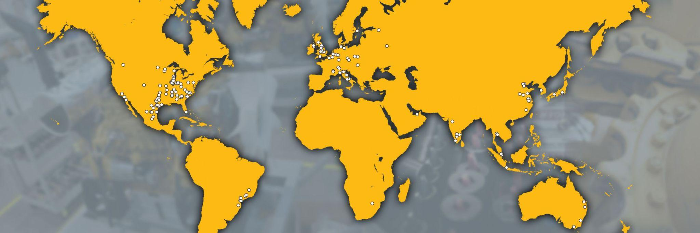

**AMERICAS**

Brazil

Mexico

United States of America

**ASIA PACIFIC**

Australia​

China​

India​

Indonesia​

Japan​

Republic of Singapore​

South Korea

Thailand

**EUROPE**

Belgium​

Czech Republic​

Eurasia & Russia​

France​

Germany ​

Hungary

Italy​

Netherlands​

Poland​

Spain​

Switzerland​

United Kingdom

**AFRICA ​**

South Africa​

**MIDDLE EAST**

United Arab Emirates

These are the countries that caterpillar inc operates around the world.

**Analysis of United Arab Emirates and United States of America**

**Brief Overview of Caterpillar**

Caterpillar Inc. is an American Fortune 100 corporation which designs, manufactures, markets, and sells machinery, engines, financial products, and insurance to customers, primarily across the construction, resource and energy industries. The company was founded in 1925 by Thomas Holt and Benjamin Franklin Caterpillar, and is headquartered in Deerfield, Illinois, United States. The company focuses on innovation of technology to improve the quality of the world’s infrastructure and natural resources. Cat products are sold in over 200 countries and territories. The company offers its customers a broad scope of product and services such as: construction, forestry, mining, oil and gas, rail, marine, paving, residential and landscape, waste and recycling, health and safety, integrated solutions, power systems, and more. Cat is a leader in sustainability and aspires to be recognized as “The Most Trusted Brand on Earth”.

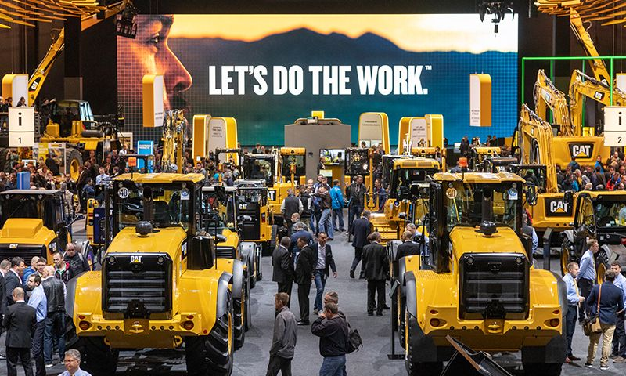

Caterpillar Inc. is one of the world’s leading construction and mining equipment manufacturers that specializes in high-quality heavy equipment and machinery. Headquartered in Deerfield, Illinois, United States, Caterpillar Inc. has over 80 years of experience in manufacturing a wide range of engines and equipment, including tractors, loaders, excavators, mining machines, generators, and much more. The company operates in the USA, the UAE, and nearly 200 other countries.

Caterpillar Inc. USA provides equipment to customers in the mining, construction, and energy industries, as well as agricultural, forestry, marine, and industrial sectors. Its UAE operations are focused on providing sales, service, parts, and support for a wide array of Caterpillar products in the Middle East region. Caterpillar's UAE facility offers its customers “The Cat Commitment”, which is a comprehensive suite of solutions, services, and customer service designed to maximize equipment uptime and performance.

In addition, Caterpillar Inc. USA and the UAE offer several innovative products and services such as telematics, fuel saving solutions, and specialized maintenance programs to ensure customer satisfaction and success. In 2015, Caterpillar Inc. USA and the UAE launched “Cat Reman”, a remanufacturing program devoted to providing customers with quality parts and equipment.

Overall, Caterpillar Inc. USA and the UAE are dedicated to providing a comprehensive suite of products and services to meet the needs of customers worldwide. The company has earned a reputation for its reliable and innovative products, exceptional customer service, and commitment to sustainability.

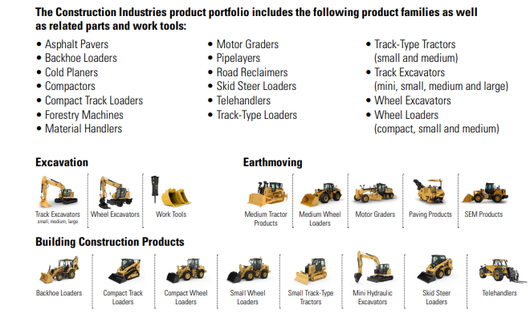

**SWOT - CAT USA**

Strengths:

1. Strong Brand Name: Caterpillar Inc. is a highly recognized brand name that is synonymous with quality and reliability. It has built a formidable reputation for producing world-class construction and agricultural equipment.

2. Diversified Portfolio: The company manufactures a broad range of products, including engine parts, diesel and natural gas engines, industrial diesel power plants, underground mining machinery, track-type tractors, turbines, and turboshafts.

3. Global Presence: Caterpillar Inc. has a strong global presence, with operations and sales offices in over 180 countries.

4. Financial Strength: Caterpillar Inc. is financially strong, with steady growth in sales and revenues over the years. The company reported net revenues of $45.5 billion in 2020.

Weaknesses:

1. Dependence on mining and construction industries: Caterpillar Inc.’s main business involves mining and construction equipment, and the company has been highly dependent on the two industries.

2. Customer Service: Although Caterpillar Inc. has improved its customer service in recent years, it still faces customer service issues like slow response times and limited support.

3. Caterpillar violated the Clean Air Act (CAA) in shipping over 590,000 engines to OEMs without exhaust after-treatment devices (ATDs) and incorrect fuel injector and fuel map settings.

4.Geopolitical tensions and trade conflicts, including the ones between the US and China, can affect global supply chains, damage demand for Caterpillar's products, and lead to an uncertain business climate.

Opportunities:

1. Global Expansion: With its global presence, Caterpillar Inc. has the potential to expand its business to new markets and increase its customer base.

2. Technology Advancement: The company has the opportunity to leverage its knowledge and expertise in technology to develop innovative new products and services.

Threats:

1. Global Economic Uncertainty: The coronavirus pandemic has caused economic uncertainty around the world, which has had a negative impact on the demand for Caterpillar’s products.

2. Market Competition: The company faces stiff competition from other leading equipment manufacturers such as Komatsu and John Deere.

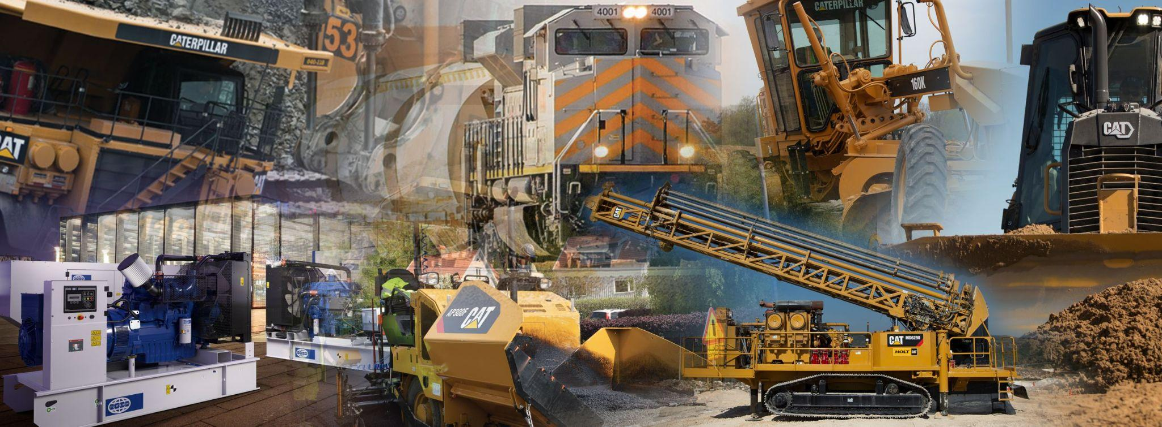

**SWOT - CAT - UAE**

STRENGTHS

1. Global Presence: Caterpillar Inc. is a global leader in manufacturing and distributing heavy machinery and equipment. The company has established operations in over 200 countries, with over 20,000 dealers and distributors worldwide.

2. Brand Recognition: Caterpillar Inc. is a well-established brand name and is known for its reliable and high-quality products. This strong brand recognition is beneficial in building trust among customers, establishing a loyal customer base, and ensuring repeat purchases.

3. In-house Research and Development Team: Caterpillar Inc. has an in-house research and development team that focuses on innovating and developing new technologies and products that improve customer experience and meet industry standards.

WEAKNESSES

1. High Operating Costs: Caterpillar Inc. spends high annual operating costs, due to the high investments in research & development, production, and marketing activities. This leads to low-profit margins and high prices for customers.

2. Recurring Environmental Issues: The company is often faced with recurring environmental issues, like accidents caused by its machinery and the effects of its production on the environment. This has caused public criticism and long-term legal liabilities.

3. Caterpillar has come under fire for its involvement in supplying bulldozers to the Israeli Defense Forces (IDF), which have been used in violent acts including the destruction of Palestinian homes and the death of an activist. Despite Caterpillar's claims that its products were sold to the U.S. government, critics argue that Caterpillar has a duty to ensure its products are not used for human rights abuses. This raises a difficult ethical question regarding how much responsibility Caterpillar should take in controlling how its products are used.

OPPORTUNITIES

1. Emerging Markets: Caterpillar Inc. can capitalize on the opportunities presented by emerging markets, like the Middle East, by introducing innovative technologies and products that meet their requirements and make use of their resources.

2. Expansion: The company can consider expansion in different regions and countries to increase its customer base and market share. For instance, Caterpillar Inc. can set up facilities in areas that have abundant natural resources, such as the Middle East.

THREATS

1. Intense Competition: Caterpillar Inc. faces intense competition from several big-name rivals, such as Komatsu and Hitachi, who are actively expanding their product range and providing customers with innovative and cost-effective solutions.

2. Difficulties in Accessing Resources: The company faces difficulties in accessing resources from certain regions, due to the presence of sanctions or governmental control, which can hamper its growth. This is especially true in the Middle East, where access to resources can be hindered by the political situation in the region.

3. Caterpillar, as a worldwide enterprise, is susceptible to changes in exchange rates, which in turn can influence its income, expenditure, and financial success. Coping with foreign exchange volatility can be difficult, especially in unpredictable currency markets.

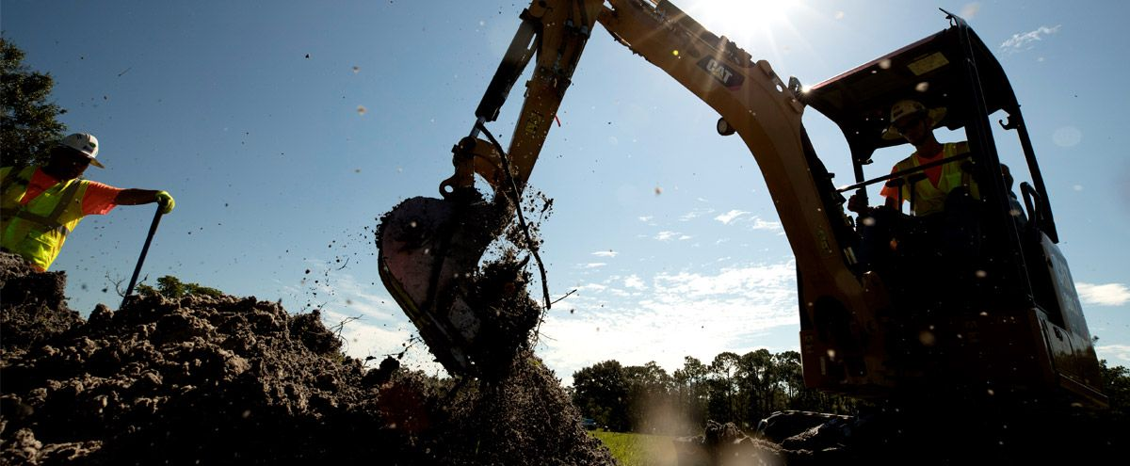

**Pestle Analysis of Caterpillar Inc.**

**Pestle UAE:**

**Political:**

The UAE has a favorable business climate and provides a wide range of incentives to businesses including zero taxation on corporate tax, excise tax, duty, and trade fee. This offers lucrative opportunities to companies such as Caterpillar Inc. due to its exports to the region. Additionally, the government of UAE also encourages investments in the country's infrastructure, which may further facilitate Caterpillar Inc.’s expansion.

**Economic:**

The Omani economy has been growing steadily in recent years with the GDP increasing by 4.9% in 2018. This robust growth has provided a stable economic environment for businesses and Caterpillar Inc. in particular. UAE also has good trade relations with many countries around the world which has expanded its trade of petroleum and natural gas and improved foreign investment. This has helped in enhancing the potential of the country for Caterpillar Inc. operations.

**Social:**

UAE enjoys a high degree of ethnic and religious diversity. This provides Caterpillar Inc. an opportunity to conduct its business operations on a level playing field without facing the resistance of any one group in society. The government also invests heavily in education, providing basic and quality education to people from all sections of society. This creates a working force that is well educated and highly skilled, beneficial for Caterpillar Inc.’s operations in the region.

**Technological:**

UAE has made great strides in the field of technology in recent years. This has enabled businesses to implement process and data improvements in a relatively short span of time. This kind of environment is ideal for Caterpillar Inc. as it enables them to perform their operations with greater efficiency. Additionally, the government has also invested heavily in research and development, creating an environment that is conducive to scientific innovations and enhancing the potential of Caterpillar Inc. operations in UAE.

**Legal:**

UAE has stringent regulations regarding foreign investment. This provides Caterpillar Inc. an assurance of the safety of their investments in the country. Additionally, the laws in UAE are applied with strict compliance which discourages anti-competitive activities and promotes fair trade practices beneficial to Caterpillar Inc. The government also supports small businesses and startups, making it easier for Caterpillar Inc. to partner with smaller companies and help them grow.

**Environmental:**

UAE has undertaken various initiatives to reduce air pollution and protect biodiversity. This helps Caterpillar Inc. to operate without facing environmental hazards and stay in compliance with the laws of the country. Additionally, the government has implemented stringent regulations regarding the safe disposal of waste material, which ensures that Caterpillar Inc. does not face any negative repercussions for its operations.

**Pestle USA:**

**Political**: The US government has imposed several trade-restrictions on Caterpillar-manufactured products, such as the imposition of import tariffs, in order to protect domestic industries. The company also faces regulations from the EPA relating to emissions and economic incentives from the government's go-green initiatives.

**Economical**: The global economy is going through a weak period, which affects the demand for Caterpillar's products and services. The exchange rates of foreign currencies play an important role in the profitability of the company since a large portion of its sales is from exports. Moreover, rising labor costs also affect Caterpillar’s profitability margins.

**Social**: There is an increasing trend in the demand for sustainable solutions for development and construction activities worldwide, resulting in an increase in the demand for earthmoving and construction equipment such as those offered by Caterpillar. The presence of numerous competitors also puts pressure on the company’s market share.

**Technological:** Caterpillar Inc. has been highly advanced in terms of technology and research and development investment. It has been able to maintain its competitive edge by using technologies such as the Converter Intelligence system and pairing efficient machines with services and cutting-edge software.

**Legal**: Caterpillar Inc. is accountable to stringent regulations relating to environmental norms, labor laws, and safety. Furthermore, import/export regulations and intellectual property rights also affect the company’s operations.

**Environmental**: Caterpillar Inc. is subject to stringent emissions regulations, endangered species regulations, mining regulations, and other environmental regulations. The company also invests in new technologies that offer eco-friendly solutions as part of its corporate responsibility towards the environment.

**Mode of Entry**

**USA:**

Caterpillar Inc. entered the US market by first establishing a corporate office in San Francisco in 1925. In 1926, the company opened its first manufacturing facility in Stockton, California. The following year, the company began producing and selling its first earthmoving equipment, the 2-Ton Tractor, which was designed and developed in the US. Over the next several decades, Caterpillar Inc. established dozens of manufacturing plants and research and development centers across the US. The company also invested in marketing, sales, and service outlets in key US markets. Today, the vast majority of Caterpillar's products are designed and manufactured in the US, and many of Caterpillar's research and development activities take place in the US.

**UAE:**

DUBAI, UAE – Caterpillar (NYSE: CAT) today announced that it will build a Regional Training Center for the African and Middle East Region (AME) in Dubai, United Arab Emirates. The Center will offer hands-on machines and power systems technical and sales training to Caterpillar’s dealers and customers in the AME region.

At an investment of more than $7 million, the approximately 1,700 m2 center will employ about 40 people, mostly high-level technical staff who will primarily be recruited from the region. The more than 7,000 technicians at AME Cat dealers have some of the most direct connections with Caterpillar customers as they service and maintain their equipment. The training they’ll receive at the new Center in Dubai will help to enhance their skills and knowledge on both product and the latest product support technologies.

“Our Training Center in Dubai is a key part of our plans for the Middle East and Africa and will ensure Caterpillar and our dealers can be relied upon for providing unsurpassed support to our customers. This is an important region for Caterpillar and we expect to see strong, continued growth for our customers, and we will grow to support that,” commented Nigel Lewis, Vice President with responsibility for Caterpillar’s EAME Distribution Division.

The Center will also feature a lab for Scheduled Oil Sampling analysis that will help meet critical customer required turnaround time of emergency samples and reduce downtime of Caterpillar products in the region. The Center will be located at Caterpillar's Middle East parts distribution center and Regional Sales and Marketing office in Jebel Ali, Dubai.

The Center is expected to be operational in the last quarter of the year 2015

**Challenges and Risks Faced**

**CAT USA:**

1. High Tariffs and Arrests: When Caterpillar Inc entered the U.S. market, higher tariffs on imported goods were imposed, and equipment was detained at various ports of entry as the government looked for evidence of dumping or illegal practices. This caused significant disruption and cost to the company as well as other companies in the industry.

2. Increased Competition: Due to the established presence of U.S. companies in the industry, Caterpillar Inc faced increased competition in the U.S. market and lowered profitability in its sales.

3. New Regulations: As the industry changed, Caterpillar Inc had to adapt to new regulations and governments, meaning new sources of compliance issues and costs related to initiatives such as the Clean Air Act and extermination of certain soil particles.

4. Strategic Alliances: Establishing strategic alliances with established and influential manufacturing companies in the U.S. industry presented additional risks, such as changed dynamics and dynamics and changes in control.

**Strategies to Tackle: USA**

1. High tariffs and arrests: To mitigate the impact of higher tariffs and arrests, Caterpillar Inc used different strategies such as finding loopholes in the legal system, lobbying and working with local governmental bodies to ensure that its equipment and goods would be allowed into the US as smoothly as possible.

2. Increased competition: Caterpillar Inc tackled this challenge by providing quality products and services that could not be replicated by its competitors. It also invested heavily in research and development to stay ahead of the competition and meet customer demands.

3. New regulations: Caterpillar Inc. worked closely with local governmental bodies to understand the changing regulations and ensure compliance with the same. It also invested heavily in training and educating its employees to ensure that they were up-to-date with the latest developments.

4. Strategic alliances: To mitigate the risks associated with strategic alliances, Caterpillar Inc employed strict control measures over its production and pricing. It also worked on developing clear objectives and protocols within its alliance partners.

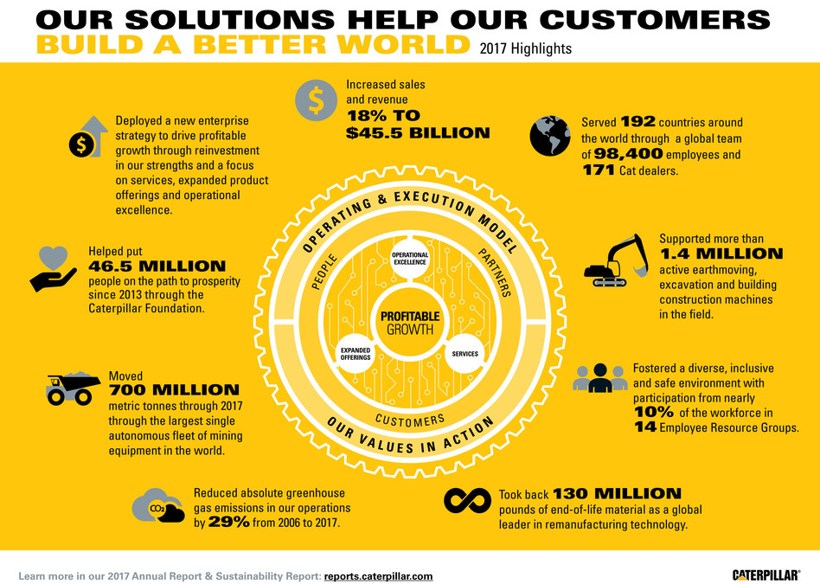

**Challenges and Risks Faced**

**CAT UAE:**

1. Access to markets: Caterpillar Inc. will need to compete with the domestic companies that are already established in the UAE market in terms of their products and services. This requires them to ensure that they have the right distribution channels and networks in place to allow for greater market penetration.

2. Regulation: The UAE has strict laws and regulations that govern business operations. Caterpillar Inc. will need to ensure that they are compliant with these regulations in order to protect its brand and minimize any risks associated with operating in this market.

3. Cost of doing business: Operating in the UAE can be expensive due to high labor costs, taxes and other expenses. Caterpillar Inc. will need to consider these factors and develop strategies to ensure the company can remain profitable.

4. Local competition: In the UAE marketplace, there is a high degree of competition. Caterpillar Inc. will need to understand the local market and develop its own competitive advantages in order to effectively compete against local incumbents.

**Strategies to tackle: UAE**

1. Developing a strong distribution network: Caterpillar Inc. has sought to expand their distribution network in the UAE in order to maximize their reach. This includes partnering with local distributors and establishing their own retail stores.

2. Adhering to regulations: Caterpillar Inc. has ensured that they comply with all relevant regulations set by the UAE government. This includes adhering to all safety protocols and environmental laws.

3. Providing product customization and localization: Caterpillar Inc. has tailored their products and services to meet the needs of the local population. This includes manufacturing certain products specifically for the UAE market and providing after-sales services in local languages.

4. Establishing local partnerships: Caterpillar Inc. has sought to build partnerships with local companies in order to better understand the local market and gain access to resources such as talent and infrastructure.

5. Gaining customer trust: Caterpillar Inc. has focused on building their brand in the UAE and gaining the trust of local customers. This includes providing quality products and services at competitive prices.

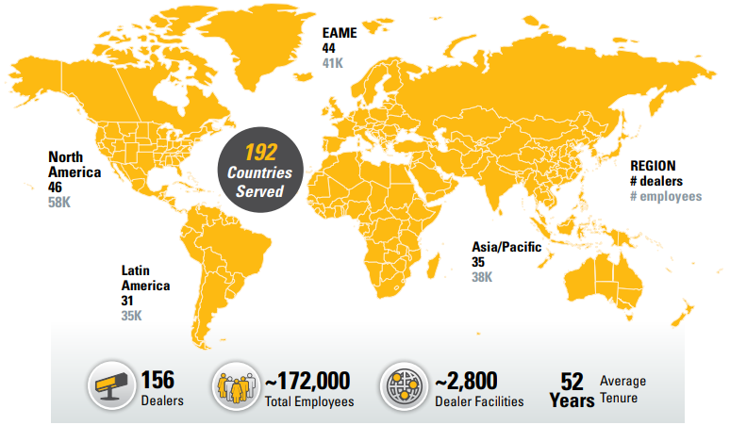

**Corporate Restructuring : USA**

Caterpillar Inc. has undergone various corporate restructurings over the years. In 2019, the company announced a restructuring plan that would include cutting around 5,000 jobs worldwide by the end of 2020, mainly in the locomotive and turbine businesses within Caterpillar and in its enterprise services division.

In order to achieve greater cost efficiency, the company also announced that it would move some of its manufacturing operations from the U.S. to lower-cost locales in Mexico and Europe. In 2020, Caterpillar announced that it was closing various production and distribution facilities in the U.S. and moving more of its manufacturing overseas. Additionally, the company announced that it was closing its Lafayette, Indiana, mining, and track-type tractor plant, eliminating nearly 500 jobs as part of the restructuring efforts.

In March of 2021, Caterpillar announced a three-year restructuring program designed to increase efficiency and reduce costs. This plan involves the closure of six additional manufacturing facilities in the U.S., the consolidation of warehouses and facilities worldwide, and the relocation of manufacturing activities to reduce costs.

In order to further improve operations, Caterpillar also announced that it is combining Global Operations with the Enterprise Services group and its Outlook Technologies religion. Additionally, the company announced that it will create a new, integrated global workflow and processes. This restructuring is expected to bring significant cost savings to the company.

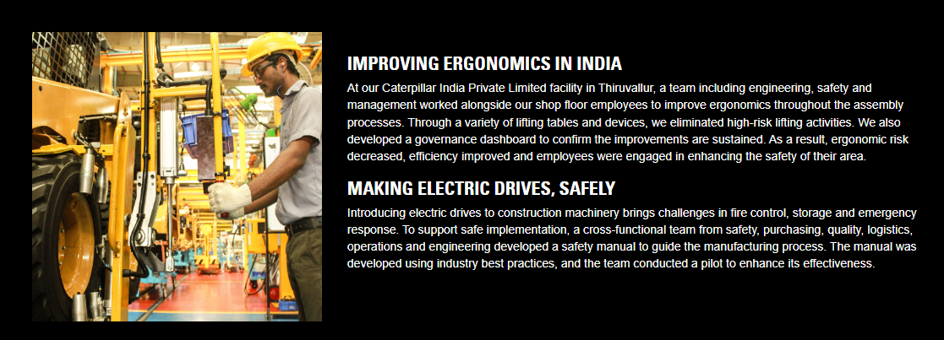

**Corporate Restructuring: UAE**

Caterpillar Inc, the international construction equipment manufacturer, has undergone several organizational restructuring exercises in recent years in the United Arab Emirates. In particular, the company has implemented a number of organizational and operational changes to align its UAE operations with the overall global strategy and goals.

The most notable changes include a focus on reducing costs and improving efficiency, reducing lead times in production, improving internal control, and creating new customer segments. Additionally, the company has implemented changes in the company’s engineering and product development processes, including the adoption of advanced technologies like 3D printing and automated manufacturing.

Caterpillar has also initiated a focus on developing more customer-oriented operations in order to better respond to customer needs and improve service-levels. This includes creating more agile production processes, assigning dedicated personnel to each customer, and introducing stricter quality control measures.

The company has also adopted a new centralized strategy that organizes the operations into localized business units. This allows for a greater degree of flexibility and better response times for customers.

Finally, Caterpillar Inc. has put in place a more rigorous system of accountability and performance monitoring, in order to ensure that all activities comply with international standards and regulations. This includes a system of independent auditing, continuous improvement

**USA vs. UAE: Caterpillar Inc Comparison of Performance:**

**Revenue**

**- USA: $47.7 billion**

**- UAE: US$220 million**

**Profit Margin**

**- USA: 14.92%**

**- UAE: 8.19%**

**Number of Employees**

**- USA: Over 100,000**

**- UAE: Around 2,000**

**Market Share**

**- USA: 30.2%**

**- UAE: 24.8%**

**Product Sales**

**US: Construction Machinery**

**UAE: Power Systems & Agricultural Machinery**

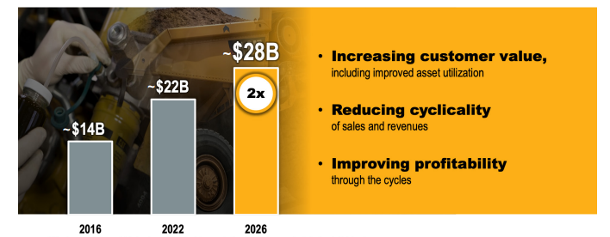

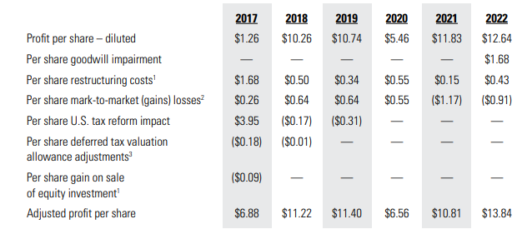

**Comparison of North America ( USA) and EAME( UAE) Financials:**

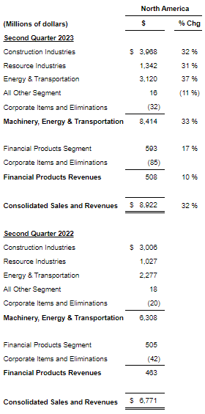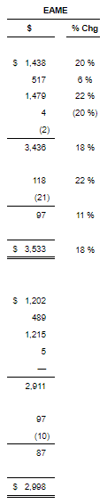

**Conclusion**

Caterpillar Being a MNC having FDI in Multiple Nations USA is the Headquarters of it and the First Market in which it has emerges and has been Dominating the market for Decades and also trying to Enter Markets like UAE where Construction and Infrastructure are the biggest Businessess and are highly in demand where it has been following strategies to compete with the existing Competitors and has been successful in it as well

Caterpillar can improve performance through differentiation. The company must increase its investment in research and development to create unique products. At present, the heavy equipment, engines, and financial services of Caterpillar are very similar to the ones available from competitors. To increase competitiveness, the firm must invest more in developing novel products.

Caterpillar can also improve its financial performance by growing its distribution network. The firm must focus on developing markets because these markets have high economic growth rates. For example, the company can increase the number of Caterpillar distributors in countries like China but the Geopolitical issues come in between so Overall Caterpillar being a Multibillion dollar company has been performing outstandingly well

**References**

1. **https://www.prnewswire.com/news-releases/caterpillar-reports-second-quarter-2023-results-301890156.html**
2. **https://www.sec.gov/Archives/edgar/data/18230/000130817922000290/lcat2022_def14a.htm**
3. **https://maaw.info/ArticleSummaries/ArtSumhendricksDefreitasWalker96.htm#:~:text=Although%20Caterpillar%20uses%20such%20figures,direct%20labor%20hours%2Fmachine%20hours.**
4. **https://www.caterpillar.com/en/news/corporate-press-releases/h/caterpillar-to-establish-regional-training-center-in-dubai.html**
5. **https://www.caterpillar.com/en/company/global-footprint/eame/united-arab-emirates.html**
6. **https://harbert.auburn.edu/binaries/documents/center-for-ethical-organizational-cultures/cases/caterpillar.pdf**
7. **https://thestrategystory.com/blog/caterpillar-swot-analysis/#:~:text=Dependence%20on%20economic%20cycles%3A%20Caterpillar's,the%20company's%20revenues%20and%20profitability.**